Manual and automation Process and Flow

Tell Me About Yourself: -
- My name is Saravanan.
- I have 4.2 years of experience in software testing.
- I have 2 years hands-on experience in selenium UI and functional testing.
- My last project is Ryderwear and it’s related to E-commerce Domain.
- And the client located on Australia.
- I am Currently working in Omega Healthcare, Chennai.

Tell Me About Yourself-2: -
- Myself “Name”.
- I have around 4+ years of experience in software testing.
- I have work experience both manual and automation.
- As part of manual testing, I have involved in all the test phases of software lifecycle like
- Requirement analysis, test plan, test case design, test environment setup, test case execution, test closure.
- Also, I do have experience in smoke, sanity, regression testing
- I have good hands-on experience in test management tools like JIRA
- Also, I have done the web applications testing and database testing as well with basic SQL queries.
- I have good experience in API testing and tested REST Api’s using postman tool.
- Also, I have 2+ years of experience in selenium automation in my career using java as the language along with TestNG.
- And build tool I have used maven
- Also for maintain source code, I have used GIT and Jenkins I have used for CI / CD
- Also, I have worked agile methodologies and participated different agile ceremonies.
- Also, I have worked framework like Data driven with POM (Page Object Model) and implemented the test case scripts when it is required.

Project Explanation: -
Wexer is a gym content distributor. They have collected the fitness instructions from athlete and other fitness instructors and provide to GYM and self-learned peoples. It’s like virtual training classes. Fitness content has been delivered through Wexer web application. Users can subscribe on Wexer and utilize the fitness instructions via Wexer application

Roles and Responsibilities: -

- My responsibility is to understand Business Requirement Specification and High-Level scenarios and to convert them into test cases & Automation scripts if required.
- we have followed agile methodology.
- We are Following 2 weeks of sprint once sprint has been planned.
- My Team Lead will assign the ticket in our name and I will pick the tickets in backlog and I will write the test cases for user story.
- Once test case has been done, I will get the approval from TL and Project Manager then after I will execute the test cases manually.
- Once manual execution is completed, I will start writing script for automation.
- We are following (n-1) spring for automation.
- Also, We have used JIRA as a Bug Tracking tool to raise the defects.
- Also, I will be demoing sprint tickets and send the weekly report regarding execution/creation/release information to teams.
- In case of regression and smoke automation, I will be triggering the build from Jenkins as well, if there are any issues in the report, we as team need to analyse and their respective methods.

Roles and Responsibilities au -
- As a automation tester, my responsibility is to understand Business Requirement Specification and High-Level scenarios and identify the modules then convert them into Automation scripts .
- And I will involve on Design and implementation of automation test strategy with my team lead.
- Also, I will create automation Test plan and getting approvals from my TL and manager.
- And I will choose selenium tools and configuring the selenium environments like Eclipse IDE, selenium dependencies and TestNG and Cucumber dependencies with proper version and selenium webdrivers so on.
- Also, as a automation tester I will involve Selenium environment setup.
- And I will involve automation framework design and implementations.
- And involved to implement the extends reports to generate test reports in automation.
- Also, I have involved to creating and debugging and running test cases and handling the changes and split the test cases for regression, smoke and sanity and maintained as a separate suite and conducting regression testing at end of each sprint.
- And finding solutions for object identification issues and implementing error handling.
- Also, implemented logs to capture all the test case execution status and maintained those logs on separate files by using Log4J library.
- Also, Co-ordinate with DEV team to solve the issues and interact with client side team to solve the issues and update the status.

Day-to-Day Activities: -
- First thing I do after login in my system. I check the active sprint in Jira for our project code.
- There I can see my assigned open tasks. After that I will check my mail if there is any important mail I need to take action on.
- Then we have our daily scrum meeting where we used to tell our previous day actions what we did, what we are planning for today and if we have any blocker to discuss.
- Product owner and scrum master help us to resolve that blocker.
- After that I need to take the pending task and do needed action whether creating test case, Execution, Defect retesting if any.
- Also, will write the automation script if needed.

Framework -
- I have worked customized framework with a combination of data driven and page object model.
- Framework have reusable packages containing all selenium commands as methods and browser base having all browser related attributes including driver reference.
- In addition have another package “utilities” with excel reader. we use it for excel read purpose (here data provider is used to fetch the details and run the test cases with number of rows present, along with Apache poi dependency).
- And property reader is for reading locators.
- For Pages we have separate package, with locators as variables and page actions as methods.
- For each and every page, we are maintaining separate classes.
- After that in the test cases packages, we will be writing the scripts, for each user story we will be creating separate methods.
- We will be creating object for the reusable methods inside test methods and using the reference we will call the respective methods.

Framework Architecture:-
- In my project, I have worked Page Object Model pattern with Data driven.
- I have used Java with TestNG along with maven to build the project and add required dependencies on POM.xml file.
- First, we have created Base class package and create the base class then added all the common functionalities like loading configuration from properties files (like application base url and Scheenshot path and Environment name so on..) and initialize the web driver, implicit wait, Extend reports.
- Also, create the object for fileinputstream in base class to read the test input data from properties and excel files.
- Then we created separate package which is called “pages”.
- In pages, we are maintaining all the web elements and locators for each page in those classes.
  - Example:- Login page, Sign up page, Products page so on..
- I have used page factory pattern and define the locators with help of @FindBy annotation.
- Then I will inherit the base class on pages class
- Then I have to initialize the page by using PageFactory.initElements() and passing webdriver and current class as an argument.
- Also, I have separate package which is called “Utilities”. In this package, we have created util classes and create generic methods for functionalities like waits, actions and capture screenshot, access the excel sheet and access the frame element, Dropdown handle functionalities so on..
- Then, we have to create the Test package and create the class for test case and test case method. Then we will create the instance for the pages class and utilities classes then we can call the required methods on test case methods.
- Also, we have to maintain the test input data on excel and we can read the excel data by using Apache POI maven dependency.
- Also, I have captured failed screenshot by using Listener. I will call the generic method of capture screenshot into onTestFailure method.
- And failed screenshot we have maintained on separate package on my project.
- Also, All the execution process of testcase methods, we have logged by using Log4j.

Selenium Framework architecture ar –
- In terms of selenium architecture, it involved few things like “Selenium client library”, JSON HTTP Protocol, Browser Drivers, Browsers.
- Selenium client library is like selenium script which is written java.
- When we run the selenium application, it will trigger the Browser driver like webdriver exe files over the JSON HTTP Protocol.
- Then Browser driver will execute our actual browsers and open the application and perform the testing activities on actual browser.
- All the test inputs and scripts will pass to Browser Drivers through JSON HTTP Protocol.
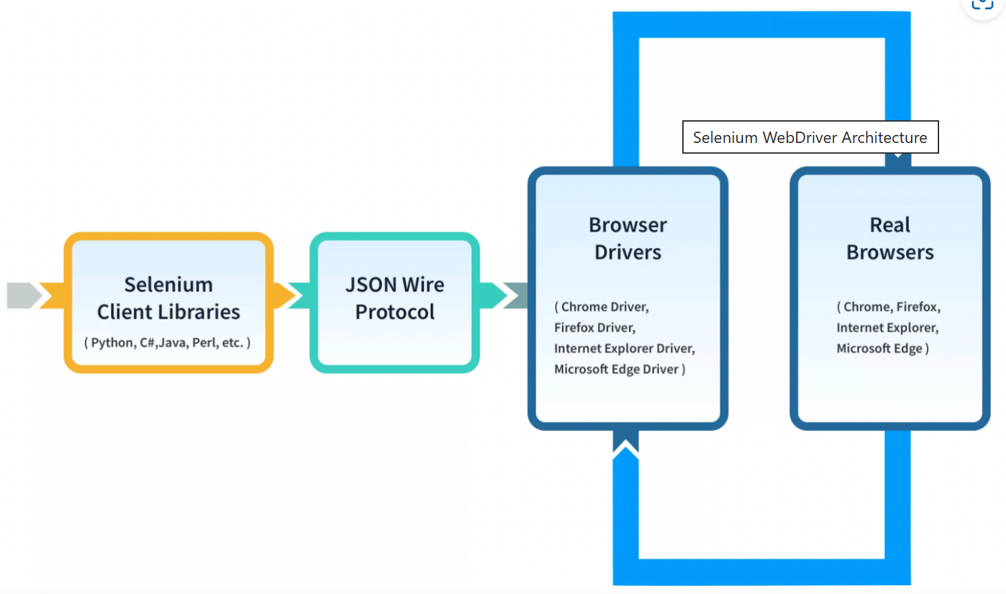

POM vs Page Factory:-

POM (Page Object Model) | Page Factory
POM is a design pattern approach | Page factory is class which is provided by selenium webdriver
It’s using to separate the page objects and scripts | It is a feature to implement POM
We can use the ‘By’ annotation to define the page objects in POM | We can use the FindBy annotation to define the page objects.
In POM, we need to initialize the every object | In Page Factory, we don’t need to initialize every object.

Advantages of POM:-
- we can maintain the code with out any duplication. We can write once and can reuse wherever it’s required.
- Also, we can separate the test cases methods and locators and utilities separately. So we can keep the code clean.
- Also, Page repository class, all the fields in the page we will define in an interface as a members. The class will then implement on interface

SDLC (Software Development Lifecycle): -
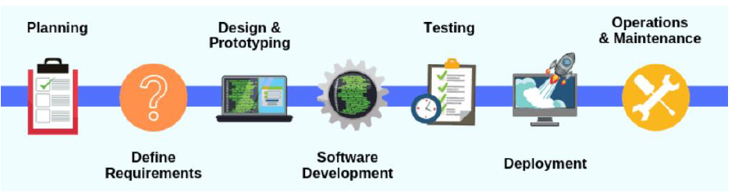
- Planning –
  - project leaders (like Manager, Scrum Master, Team Lead) evaluate the terms of the project during the Planning phase.
  - Later, requirements gathering is considered as part of planning to determine what the application is supposed to do and its requirements.
  - Those details will be created by using SRS (Software Requirement Specification) documentation.
- Design – we will prepare System and software design documents as per the requirement specification document. It includes High-level and low-level documentations.
- High-level Design (HLD)
  - Brief description and name of each module.
  - An outline about the functionality of every module.
  - Interface relationship and dependencies between modules.
  - Database tables identified along with their key elements.
  - Complete architecture diagrams along with technology details.
- Low-level Design (LLD)
  - Functional logic of the modules
  - Database tables, which include type and size
  - Complete detail of the interface
  - Addresses all types of dependency issues
  - Listing of error messages
  - Complete input and outputs for every module.
- Coding - Once the system design phase is over, the next phase is coding. In this phase, developers start build the entire system by writing code using the chosen programming language. tasks are divided into units or modules and assigned to the various developers.
- Testing –
  - Once the software is complete, and it is deployed in the testing environment.
  - The testing team starts testing the functionality of the entire system.
  - This is done to verify that the entire application works according to the customer requirement.
  - During this phase, QA and testing team may find some bugs/defects which they communicate to developers.
  - The development team fixes the bug and send back to QA for a re-test.
  - It will continue until the applications is bug-free and stable, and working as per the client need.
- Deployment –
  - Once the testing is completed and there is no bugs and errors are left in the application, then application will be start to deployment phase.
  - Based on the feedback given by project manager, the application will be move into UAT and check for deployment issues if anything.
- Maintenance –
  - Once the application has been deployed into production environment and end users start to use the application, there are few activities need to follow.
    - Bug Fixing – Generally, bugs are reported because of some scenarios which are not tested at all.
    - Upgrade - Upgrading the application to the newer versions of the Software.
    - Enhancement - Adding some new features into the existing software.

SDLC Models: -

Waterfall Model wm -
- All the Requirement analysis, Design and development, Testing, Maintenance will happen in single shot.
- It’s a one-time delivery process.
- We can choose waterfall model for the small projects.

Agile -
- Instead of deliver all the requirements in a single shot, requirements will be delivered to the customer as incremental basis.
- Customer requirements for the project will be collected by BA (Business analyst).
- Sprint Basis, Requirements will be split in small set of pieces.
- Sprint means - Deliverable duration
- We are following 2 weeks of sprint. It means deliver user stories, 2 weeks once.
- Also, In Agile We are following few meetings like.
  - Sprint Planning (grooming)
  - Walkthrough meeting
  - Scrum meeting
  - Sprint review
  - Retro spectrum meeting
Sprint Planning (grooming)
Sprint planning, we will move the product backlogs to the sprint backlogs and prioritization will be done by the scrum master.
And, estimations and schedules also will happen during sprint planning.
I will split the requirement in the smaller pieces and for the each piece I will put the estimation and I will put the effort in hours and I give the report to my lead, My lead will consolidate and give the revised estimation.

Agile (or) Sprint Ceremony-
- Sprint planning
- Sprint review
- Sprint Retrospective
- Daily scrum meeting

product backlog -
The Product Backlog is specific to the entire goal of the product.

sprint backlog -
The Sprint Backlog is specific only to the Sprint goal in a particular Sprint.
Sprint Goal will remain the same for the Sprint while the Sprint Backlog may evolve during the Sprint subject to the Sprint.
IN THE BACKLOG SESSION, WE WILL MOVE THE PROJECT BACKLOG TO SPRINT BACKLOG
Walkthrough Meeting
Walkthrough meeting is like selected sprint backlogs and its functionalities will be discussed in this meeting.
In this meeting, peoples will involved like
- Dev team lead
- Business team lead
- Testing team lead
- Client-side co-ordinator (On site Co-ordinator)
- Client – Product owner
Above list first 4 of them will explain about the 10 stories and get approval from the client to pick the 10 stories for this current sprint.
Those Stories will be created as a JIRA ticket in the JIRA tool
Jira tickets are assigned to the team members.
Scrum Meeting
- Daily basis follow-up of requirements and status of the user story which is working.
(Here all employees of the team must be provided the status of current task which they are doing).
- scrum meeting will happen daily basis and Scrum master will initiate the meeting.
- Scrum meeting, we will discuss about each points status by resource wise
- after completion of scrum meeting, we will send MOM (minutes of meeting email) to the team
MOM contains, what are the points are discussed and committed in the scrum.
Moto of the scrum meeting is discussion about
- What we completed yesterday?
- What will get completed today?
- What is the plan for tomorrow?
Last day of the sprint, we will perform the sprint review and retro meeting will happen.
Sprint Review- meeting
Completed points will get shown as demo to the product owner by scrum master and reviewed in the meeting to ensure the completeness.

Retro spectrum Meeting- (Retro Meeting) :
Retro meeting will happen at last of the sprint, Purpose of the meeting is, how to improve the team performance and improve the quality of delivery by each sprint.
Existing issues and learnings will be discussed and apply the learnings in the upcoming sprints.
each resource of our team will discuss here
- What are the challenges we faced in the current sprint?
- What we learned in the current sprint?
- New automation/ new ideas may be discussing to overcome the release-oriented problems
- If any of situation, our release date extended then, or else any slippages in the release then those problem and solutions will be discussed in the meeting.

Agile Ensures Parallel processing – Advantages of Agile model
- Parallel work of dev team and testing team
- Requirements will come as Requirement Specification Document (RSD)
- Based on the RSD, Dev team will start the development process, testing team will start the Test case preparations
- If dev team Delivers the build, then QA team will start executing the test cases which already prepared
- Instead of delivering all project points at single shot, agile ensures incremental delivery
Continuous scrum meeting and customer meeting and follow-ups are used to come out from the mis-communications in the requirements.

JIRA -
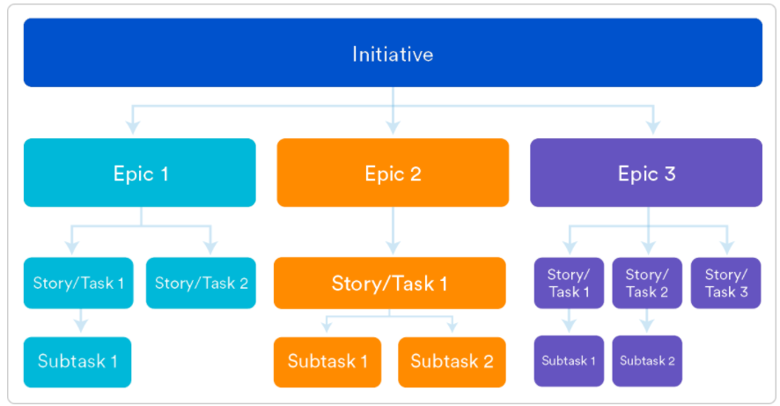
Epics are larger bodies of the requirement
Epics will be broken down and created as stories
And Stories will be broken down and created as tasks and sub tasks
Those tasks will be assigned to us.
JIRA tool will have and display the few information like:-
1. ticket id
2. ticket description
3. ticket assigned date
4. expected completion date
5. assigned to
6. assigned by
7. attachments
8. Status - in dev/ in sit / in UAT / in prod
9. comments -
10. effort in hours
JIRA tool having each log-in credential to each user
manager having super user login
If Manager logged in then,
manager able to see each ticket status by individual users
- each ticket efforts in hours
- number of completed tickets in dev team
- number of pending tickets by dev team
- number of completed tickets in testing team
- number of pending tickets by testing team.

us -
- User stories is a requirement for the application development which is split as points.
- Each stories will have story points for the particular functionality.
- Single user story will have at least 5 story points.

User Stories acceptance criteria: -
- Acceptance criteria means whether the application functionality of user story meets the expected results are not and it can be accepted by product owner.
- It will be reviewed by product owner and BA (Business analyst).
- For example, in my previous project, application have a feature like download historical report in CSV, PDF and text file formats.
- In this situation, we can follow criteria as per story points like
  - While download the historical report, user should select the specific report time period and “To date” should not be feature date.
  - While download the historical report, if user does not provide the date range, then reports should not download on application.
  - Once download the reports, user should able to view the download file.
  - Also, reports should be generated in all the accepted file formats like CSV, PDF, text so on.
  - Also, While download the reports, file should be download the proper report name.
  - While open the file, what all the columns to be displayed.

QA TESTING | Team Members: -

Testing Team will contain People like
- Manager – Team manager will Tracking of the Team / Create the Test Strategies
- Test Lead - Test Lead will Tracking of the Testcases and Test engineers – Create the test plans
- Test engineers – Test engineers will Creation of Test cases and Execution of test cases

Documentations Involved
- Test Strategy Document creation
- Test Plan Document Creation
- Test Case Document Creation
- Traceability Matrix Document Creation
- Test Closure Document

Test Strategy- Document creation
Usually It’s Created by Test Managers
Once It Created then, It Will not change, it is a Static Document
This Contains like
- Strategies for testing
- Objectives,
- Scope to be tested
- test processes,
- team reporting structure,
- client communication strategy,

Test Plan tp -
Usually, it’s Created by Test Lead
It will Create based on Test Strategy document
Small changes are allowed in the document after the creation
So, it is Dynamic document
This Contains like
- Test plan id,
- features to be tested,
- test techniques,
- testing tasks,
- features pass or fail criteria, test deliverables, responsibilities,
- schedule

Test Case tc -
Test case will created by Test Engineers
And it will created Based on Test Plan, Dynamic Document, it will get updated frequently
Ticket Wise Test case we will get prepared and test case contains like
- JIRA_id
- Test Case id
- Test Case information
- Required inputs
- Expected Output
- Actual Output
- Result.
Those all are included in the test cases.

RTM -
RTM is a Requirement traceable matrix and It’s using to track the few things like.
- Summarized report of the test case document
- Prepared by Test Engineers
- Number of test cases will be grouped as JIRA ticket wise
- We can see the titles of requirement Id, Requirement description, list of test cases and Number of cases pass and fails in this document
- This document can be mapped with requirements, and we conclude all the requirements are properly completed testing or not.
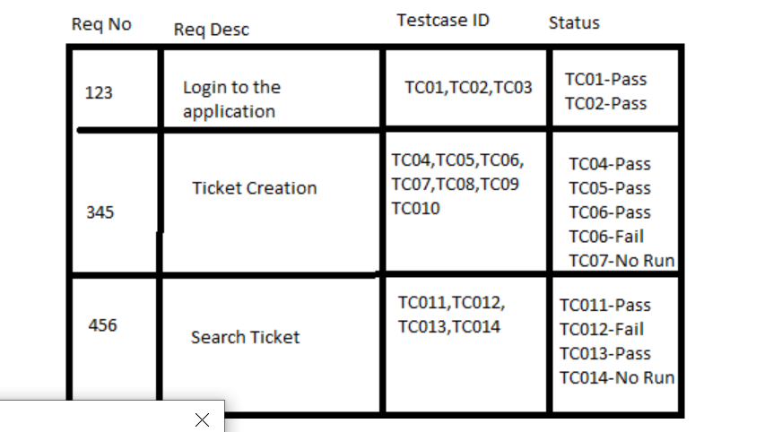

Types of Testing -

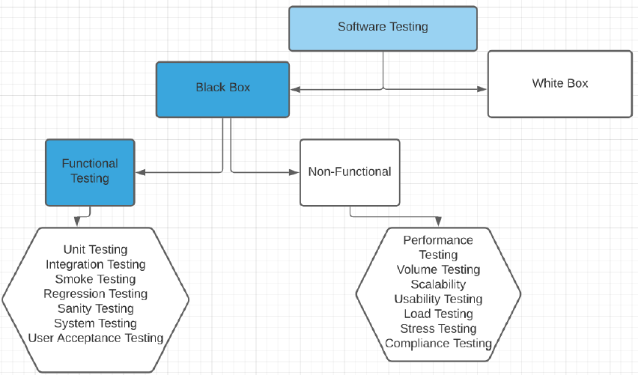
Black Box Testing - black Box Testing (SIT team will do) is one of the testing type. which testing team can test the application without knowledge of internal code structure.

There are 2 categories: -
Functional and Non-functional testing.
- Functional Testing – it’s verify all the functionality of the application as per the business requirement. Like.
  - Unit testing
  - Integration testing
  - System testing
  - Smoke testing
  - Sanity testing
  - Regression testing
  - Alpha testing
  - User acceptance testing (UAT)
- Non-functional Testing – it’s verify the behaviour and performance of the application. Like
  - Performance testing
  - Stress testing
  - Usability testing
  - Load Testing
  - Volume testing

Functional Testing ft -

- Unit Testing –
  - It’s verified the specific part module and unit working as per the requirement.
  - Mostly, it’s done by developers.
- Integration Testing –
  - Integration testing will perform, if the new module integrated into existing functionality. Whether the new functionality working as expected.
  - We used to have to verify that integrated units are working without any errors and bugs.
- System Testing –
  - It will verify, once all the modules and units are integrated and testing completed, we will perform end-to-end testing and confirm the application working as per the requirement.
  - We need to check both main and interconnected systems.
  - Like user interface and functional data flow.
  - We have to perform completed end-to-end testing.

Smoke Testing st -
  - Smoke testing checks if the software build is stable and can be used by the QA team for further testing.
  - If the deployed build is not stable and it’s breaking main functionalities, then QA team will reject the build and will not proceed testing further.
  - Example:-
    - Login to the application is working or not.
    - All the user interfaces are opened or not.
    - Application URL is opening the application or not.

Sanity Testing st -
- sanity test is the quick evaluation test.
- It is used to validate the basic functionalities of the applications is working fine.
- existing bugs have been fixed and no further issues are introduced due to these changes.
- It will happen at the last of the testing phase, and it will happen in the production or pre-prod environment.
- It’s kind of subset of regression testing.

Regression Testing rt -
- Usually, it will perform every end of sprint.
- Is a kind of maintenance testing.
- If the build released by the development team, we need to validate the build and also the impact of the build.
- Regression testing, we have to concentrate dependent functionalities which are relevant to the build those has to be validated.
- ensures that no new bugs have been introduced after adding new functionalities to the system.
- Regression Suite will get updated in each sprint.
- Frequent failure cases, direct test cases of the functionalities those cases will get identified and we will add it into our regression suite in each sprint completion.

retest -
- Retesting is done to make sure that the tests cases which failed in last execution are passed after the defects are fixed.

Difference Retest and Regression Testing –
Regression Testing | Retesting
The purpose of Regression Testing is that new code changes should not have any side effects to existing functionalities. | Re-testing is done on the basis of the Defect fixes.

- Alpha Testing –
  - it will perform by the organization.
- Beta Testing –
  - Beta testing will be done by the end user of the project.
  - For example, software beta versions are released by the organizations to get the end user comments and reduce the bugs in their project while in actual release of the product.
- UAT (User Acceptance Testing) –
  - It will do by the product owners and client.
  - This will happen, once application deployed into UAT environment.
  - Product owners and client will confirm the application working flow as per the requirement.
  - UAT will be performed every release of sprint.

Non-Functional Testing types NFT -
- Load Testing –
  - It is a type of Non-Functional Testing.
  - the purpose of Load Testing is to check how much load or maximum workload a system can handle without any performance degradation
- stress Testing –
  - it’s used to perform when a system is stressed beyond its specifications in order to check how and when it fails.
  - This is performed under heavy load like putting large number beyond storage capacity, complex database queries, continuous input to the system or database load.
- Performance Testing –
  - Performance Testing is done to check whether the system meets the performance requirements.
  - Different performance and load tools are used to do this testing.
  - There are lot of tools to do the performance testing in market like Apache JMeter and Load runner so on.

Other Testing Types: -
- Ad-hoc Testing –
  - It can be performed without any proper plan like without test case document and no reference.
  - The objective of this testing is to find the defects and break the application by executing any flow of the application or any random functionality.
  - Ad-hoc Testing is an informal way of finding defects and can be performed by anyone in the project.
  - It is difficult to identify defects without a test case but sometimes it is possible that defects found during ad-hoc testing might not have been identified using existing test cases.
- Monkey Testing –
  - Monkey Testing is carried out by a tester assuming that if the monkey uses the application then how random input, values will be entered by the Monkey without any knowledge or understanding of the application.
  - The objective of Monkey Testing is to check if an application or system gets crashed by providing random input values/data.
  - Monkey Testing is performed randomly and no test cases are scripted and it is not necessary to be aware of the full functionality of the system.
- Exploratory Testing –
  - Exploratory Testing is informal testing performed by the testing team.
  - The purpose of this testing is to explore the application and looking for defects that exist in the application.
  - Sometimes it may happen that during this testing major defect discovered can even cause a system failure.
  - During Exploratory Testing, it is advisable to keep a track of what flow you have tested and what activity you did before the start of the specific flow.
  - No testing document and test cases required to perform this.
- Happy Path Testing –
  - test the application successfully in positive flow.
  - For example – in login page, give the proper username and password and validate whether it's logged in or not.
  - Perform without any negative user input combinations like correct username and wrong password and wrong username and correct password so on..
- Vulnerability Testing –
  - it’s used to perform any security issues on application and hardware and network level.
  - It will help to confirm application working without any security flaw.

Software Testing Lifecycle STLC -
Entry Criteria:
- Requirement Analysis – I will understand the requirement completely from the RSD document.
- Test Planning – Plan for the test has been created.
- Test Case Development – Test case document preparation will be done in Test Case Development phase
- Test Environment Setup – Setup has been completed with respective to the requirement
- Test Execution – Test cases are executed in this environment and filling the test results in the test case document.
Exit Criteria
- Test Cycle Closure – will close the testing cycle after completion of all bugs.
- STLC Phases along with Entry and Exit Criteria.

Defect- Bug- LifeCycle D -
- Defect will be created as status of New, and it will be assigned to the developer with assigned status
- Developer side it will shows in the open status and developer will work on that issue and they will change in the status of fixed.
- Then it will be back to use in the status for the pending to retest, we will retest the defect and if it works then it will change as verified and closed status.
- If it again reopens then it will go to open status.

Defect- Deferred- Status
- If Tester identified the bug and it is not fixed by the dev team and dev team wants to
go-ahead to release with the bug. then that bug is called deferred bug
- Deferred bug will not be in Priority one, and also there is no impact of the functionality
- We have to properly intimated to the customer about the bug and we have to release the build
- We need to ensure that particular bug will get fixed in upcoming release

Rejected Bug
- If the bug is invalid and the bug raised duplicated then developer can reject the bug.
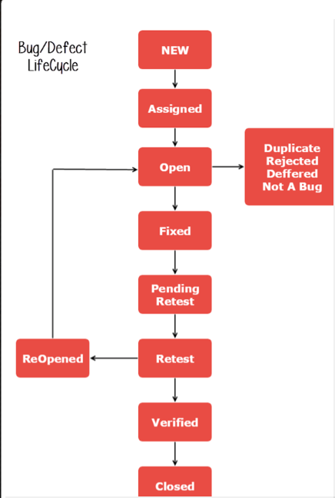

Severity Se -
Severity means How the functionality of the application is affected based upon the bug
on that severity fixed
- Critical: This defect indicates complete shut-down of the process, nothing can proceed further.
- Major: It is a highly severe defect and collapses the system. However, certain parts of the system remain functional.
- Medium: It causes some undesirable behaviour, but the system is still functional.
- Low: It won't cause any major break-down of the system.

Priority Pr -
Priority means How Soon the bug has to be fixed.
- Low: The Defect is an irritant but repair can be done once the more serious Defect has been fixed.
- Medium: During the normal course of the development activities defect should be resolved. It can wait until a new version is created.
- High: The defect must be resolved as soon as possible as it affects the system severely and cannot be used until it is fixed.

Severity and Priority example –
Severity – Priority | Examples
Low Severity – High Priority (LSHP) | 1.Spell error on logo.  2.it will not affect the functionality (severity) but created bad impression on company brand.
High Severity – Low Priority (HSLP) | 1.If application have 2 pages like “reports generator” and “products”.  2.If the “report generator” screen is mistakenly given the name as “products”.  3.It will confuse the client which is what screen.
Low severity – Low priority (LSLP) | 1.let’s consider, If there are 2 text box fields like minimum and maximum.  2.if we give input as 21 and 31 respectively,  3.The warning message “Min value should be less then Max value”  4.It’s spelling and grammar error.
High severity – High priority (HSHP) | 1.let’s consider, if the list of product checkout displayed on the screen.  2.Also, it’s has “Edit” and “Delete” fields to perform modification.  3.If those “Edit” performs “Delete” action then it’s high severity and high priority.

Priority Estimation Hours –
- If it’s the Critical and breaking the core application functionality means, it would be 4 to 5 hours estimation.
- If it’s the High, then it would be 6 to 8 Hours estimation.
- If it’s medium, then it would be 8 to 12 Hours estimation.
- If it’s Low, then it will be 12 to 24 Hours estimation.

Risks may include Risk -:
- Tight timelines.
- Undefined project scope.
- Insufficient resources.
- Continuously changing requirements.
- Natural disasters.
- A high number of test builds,
- Insufficient regression time
- Unavailable prerequisites
- Incomplete validation
prioritizing testing sequences by placing functionalities more crucial to software performance at the front of the testing queue
- Risk mitigation – Renewed planning to avoid the risk.
- Risk acceptance – The risk was not eliminated in prior releases, and is therefore accepted in the current release.

Test Scenario Vs Test Cases ts vs tc -
- For each Test Scenario we can create multiple test cases
Example: For login page:

- Login page has to be loaded
- Login Button Has to be enable once I provided to the inputs of username and password field
- Validate username text Box
- Validate password Text Box
- Validate Login Button
- If proper input to the username and password then, that page navigates to next screen
- Reset password link has to be validated
- Login page Company name, spelling mistakes, Logo these things validated (Cosmetic check)
For Each and every Test scenario, we have to provide multiple test cases
- We have to use the link and press enter loaded or not
- Refresh the login page again, it has to be reloaded.

Choose JIRA Tickets for Regression and Smoke: -
- For Regression, We need to pick the repeated that is reusable test cases in future releases, so to Include the test cases that have frequently yielded bugs.
- Also to include the test cases that verify core features of the application we need to consider.
- For smoke, pick the high level cases like login, payment, application opening or not etc.

Estimation of user stories: -
- It’s all depends on the complexity and functionality of the application.
- We will be estimating it through pointing poker and it will a Fibonacci series say 1, 2,3,5,8 and so on.
- When estimating new stories we will consider if its minor UI changes or text change in single page will go with 1 or 2, for page reference or interaction with 2 or more pages 3 to 5 stories
- If related to database and API will go bigger.

Negative items should talk during sprint retro meeting: -
- Scenarios like if the build has been delivered very late by DEV team.
- If the Environment is not ready to proceed testing.
- There is database problem and no data for the ticket then our scrum master will note it down as action items to rectify for the next week.

Test case Tool Used:-
- Test case creation we have followed in excel and project tracking we have followed in JIRA.

Weekly reports contains WR -
- Test case creation and execution status.
- List of defects which is raised and need to tracked.
- I will tracking it from JIRA and follow up with my team.

Recently faced challenges RFC -
I have recently faced Challenges in automation: -
- Challenges: we have a scenario ,there we need to validate excel file through upload/download. But there is frequent header changes based on user role. So first header change and next validating manually takes time.’

So I have created a separate reusable class for the validation , first I will find the column name in the respective row after that iterate from the next field to take the row values
I will save it in list and compare the input values, if I found then I will start taking the values.

Also,

- most of the times developer gives the build very late.so this leaves us very less time to complete. Here completeing all stories on time is difficult. So we will test high level functionalities first and for small functionalities we run the automation to provide sign off.
- Here plan and prioritise the test cases before the release testing is a challenge and our lead will ask us to do document everything from high to low level cases in excel to process.

Team Handle and Client Interaction:-
- Yes. in the absence of my lead I will handle for some hotfix(minor bug fix) releases.
also, I do have client interaction by clarifying doubts in user stories and also shown demo frequently.

List - key column you will have in your test case- document?
- Requirement id (JIRA ID)
- Test case id
- Test case description
- Test Inputs
- Expected output
- Actual output
- Test Result

List - key column you will have in your bug report- document?
- Id
- Title
- Priority
- Severity
- Description
- Steps
- Category
- Reported By
- Assigned To
- Status
- Resolution Type
- Build-no
- Regression(Y/N)

Dev team not accepted the bug then, what is your approach?
- I will raise the bug only after complete understanding of RSD document
- if they are not accepting then, I will listen them the reason of not acceptance and I will try to understand, their thoughts about the issue
- If the defect is really wrong one then, they can reject the bug with proper comments
- If the defect is true and not accepted by the developer then,
- I will explain the same defect in the customer point of view to the development team
with proper input and expected outputs.

Critical Bug- identified at last minute, please talk about the bug
- At Final Just I have validated in basic check in sanity test, one of the applications accepts the errored data. Even that same case is passed in the previous execution.
- Everyone concentrated validation of the data, but this validation is done by the code unfortunately dev team forgot to enable the program code in the environment.
- If I missed the sanity test then, obviously it may become the big issue and escalation.
- I can say this issue is the simple careless mistake and identified in the right time.
- Same issue if we missed then it may give huge impact to the team.
To avoid this kind of issues in future, we have prepared a document which contains list of checklists to be followed in the production release.

Testing is delayed- and it is not as per the expectation and we cannot complete the testing with in the time, how you handle the situation?
- I will try to close the tickets which are in the high priority.
- If we complete all priority tickets then we can proceed the conditional sign-off, and we can convince the client.
- I will plan the low priority tickets in the form of dot release or next sprint release.

JIRA AS TEST MANAGEMENT TOOL JIRA -
- Jira we are using for test management and ticketing purpose.
- In the Jira story points will get created and assigned to the team members.
- We will create the test cases and bug reports in the excel sheet and we will upload them in the Jira by using of the import csv option in the Jira.

How to create bugs in the jira
- After finding the bugs, I will recheck that is the valid bug or not
- I will create the bug by using of create button and I will select the issue type as Bug.
- I will put the input and output details which used to execute the test case
- I Will attach the screenshot for the reference and I will put the priority and severity
- Finally, I will assign the bug to the developer.

Core Java Concepts Java -

Rate yourself for Java:-
- I will rate 3.5 out of 5.

Can you tell me Oops concepts and relate it with your Framework oops -
- Inheritance –
  - Inheritance is the feature in java by which one class is allowed to inherit the features (fields and methods) of another class.
  - We can apply Inheritance in our Automation Framework by creating a Base Class to initialize the WebDriver interface, browsers, waits, reports so on..
  - we can extend this Base Class and its methods in other classes like Tests or Utilities.
- Abstraction –
  - Data Abstraction means to handle complexity by hiding unnecessary details from the user.
  - We can achieve abstraction by using abstract class and interface.
  - But in interface, we can achieve 100% abstraction because all the methods will be abstract method.
  - In Selenium, WebDriver itself as an interface.
  - Example:- WebDriver driver = new ChromeDriver()…
  - I can initialize any driver like edge and Firefox (gecko driver) with help of WebDriver interface.
  - Also, We can apply Data Abstraction in a Selenium framework by using the Page Object Model.
  - We define all our locators and their methods in the page class. We can use these locators in our tests but we cannot see the implementation of their underlying methods.
- Encapsulation –
  - Encapsulation is defined as the wrapping up and code and data into single unit.
  - Example:- Declare variable as private and we used to set and get with help of getter and setter methods.
  - In page object model class, we declared locator data members with @FindBy annotation and initializing of data members with help of constructor.
- Polymorphism –
  - it’s using to perform single action with different ways. It can be achieved with Method overloading and Method overriding.
  - Method overloading –
    - When there are multiple methods with same name but different parameters then these methods are said to be overloaded.
    - Methods can be overloaded by change in number of arguments or/and change in type of arguments
    - Example - In Selenium Automation, Implicit wait is an example of Method Overloading. In Implicit wait we use different time stamps such as SECONDS, MINUTES, HOURS.
  - Method Overriding –
    - It occurs when a derived class has a definition for one of the member functions of the base class. That base function is said to be overridden
    - Example:- In Selenium Automation, Method Overriding can be achieved by overriding any WebDriver method.
    - we can override the findElement method.

Difference between interface and abstract
Interface | Abstract Class
Interface only contains abstract method | Abstract class can have abstract and non-abstract method
Interface support multiple inheritance. We can implement multiple interface in a single class | Abstract class doesn’t support the multiple inheritance because we can inherit only one class at a time
Interface data members can have only static and final variables | Abstract class data members can have final, non-final, static and non-static variables.
Interface can’t provide the implementation of the abstract method. | Abstract class can provide the implementation of the non-abstract method
Interface can be implemented by using “implements” keyword | Abstract class can be extended by using “extends” keyword
Interface data members can have public and default access modifiers only | Abstract class data members can have public, private, protected and default access modifiers.

Can an interface implement or extend another interface?
- Interfaces don’t implement another interface, they extend it.
- Since interfaces can’t have method implementations.
- there is no issue of diamond problem so multiple inheritance is possible.

Can you override private or static method in Java
- we cannot override private or static method in Java.
- if we create similar method with same return type and same method arguments that's called method hiding.

Can you overload main method in Java
- Yes, We can overload the main method in java but JVM only calls the original main method.
- it will never call our overloaded main method.

Constructor -
- it’s used to initialize the value of object.
- Constructor will be invoked while instance getting called.
- Even, If not provide constructor explicitly, the default constructor will be getting invoke while instance called.
- Constructor has two types – Parameterized and Non-parameterized constructor.

Static -
- it’s will declare with data members like variables and methods.
- It’s class related and it’s using to store the values into memory while class loading and it will have the value until application getting terminated.
- It’s mainly using for memory management purpose.
- If we declare variable and method with static keyword, we can call it another class without instance creation.
- Example:- Classname.Variable_name and Classname.MethodName()
- Also, We can’t override the static method because static method usually work with static binding at compile time but method overriding is dynamic binding at runtime. So we can’t override static methods.

Static method vs Non-Static method:-
Static | Non-static
1.If we have only one copy of object, then we can use static method | If we have multiple copy of object, then we can use the non-static method.
2.Static methods are useful if we want to call the method multiple times with out creating object. | Non-static methods are useful if we need to call the method in non-frequently.
3. in terms of memory, Static variables and methods will be allocated the memory at the time of application start. Java will release the memory once application terminated. | For Non-static method, memory will be allocated at time of object creation and released the memory once object execution is completed.

Static vs Dynamic Binding:-
Static Binding | Dynamic Binding
Static Binding will happen at compile time. For example: - private fields and methods, final fields and static members. | Dynamic binding will occur at runtime. Compiler don’t know that particular method going to be called. For example:- Method overriding.

This -
- It’s using to refers the current object (class) in a method or constructor.
- Usually, we will use this keyword to avoid the duplication problem.
- For example:- In constructor, If the variable name and parameter name both are same, we differentiate by using “this” keyword.
- “this” keyword can be used to.
  - Invoke current class constructor
  - And invoke current class method
  - And return current class object

Final -
- it’s using to define the constants.
- If the variable marked with final keyword, we cannot change the variable value at runtime.
- If we declare final on class level, we can’t extend the class.
- And, If we declare final on method level, we can’t override the methods of parent class

Super -
- it’s using to refer the parent class data members into child class.
- It can applied for variables and methods and constructors.

Can we overload and override the constructor –
- we can overload the constructor but we can’t override the constructor.
- If we try to override the constructor in the sub class, java compiler treats it as a method and expects a return type and throw the compile time error.

Difference between Constructor vs Method cons -
Constructor is using to initialize the object | Method is using to reuse the code without writing the code again
Constructor Implicitly invoked while creating instance for the class | Method we have to call it manually
Constructor will not have any return type | Method will have return type
Constructor name same as class name | Method name we can provide our own. We can use any name for method

Exception ex -
- We can handle the exception with try, catch, finally block (or) throws and throw keyword.
- There are two types of exception like checked and unchecked exception.
  - Checked exception –
    - It will occur at program compile time.
    - Example – IOException, ClassNotFoundException and SQLException.
  - Unchecked exception –
    - It will occur at program runtime.
    - Example – NumberformatException, NullpointerException, ArrayIndexOutOfBoundException so on..

Selenium Exception ex -
- Timeout Exception: This exception is thrown when a command performing an operation does not complete in the specific time.
- NoSuchElementException: This exception is thrown when an element with provided attributes is not found on the web page.
- ElementNotVisibleException: This exception is thrown when the element is present in DOM (Document Object Model), but not visible on the web page.
- StaleElementException: This exception is thrown when the element is either deleted or no longer attached to the DOM Object. We can handle this by using
  - Try, catch block (or)
  - We can handle by using refreshed method in explicit wait.
  - Like wait.until(Expectedcondition.refreshed(Expectedcondition.presenceofElementLocated(locator)))

How to Handle the Exception ex -
- We can use try,catch and finally block
- Using throws keyword.
- Using throw keyword

Throws and Throw –
Throws | Throw
It’s using to declare the exception at method signature | It’s using to declare the exception at method body. Mostly we will use in if and else statements.
We can declare any number of exceptions as comma separated in method signature.  But only one exception will raise at a time | We can throw only one exception at a time.  We can’t have more than one exception declaration in method body.

Custom Exception Class Creation ex -
- We can create new class and extends with Runtime exception.
- Create the constructor on exception class.
- If exception needed, we can create constructor with parameter
- We can call the parent class constructor with child class constructor with help of “super()” keyword.
- We can use this custom exception in another by using “throw” keyword.

finally -
- It’s a block of code which will be execute always wheatear exception occurred or not.
- Finally block will follow with try-catch block.

final & finally & finalize -
final | finally | finalize
final is the keyword and access modifier which is used to apply restrictions on a class, method or variable. | finally is the block in Java Exception Handling to execute the important code whether the exception occurs or not. | finalize is the method in Java which is used to perform clean up processing just before object is garbage collected.
Final keyword is used with the classes, methods and variables. | Finally block is always related to the try and catch block in exception handling. | finalize() method is used with the objects.
(1) Once declared, final variable becomes constant and cannot be modified.  (2) final method cannot be overridden by sub class.  (3) final class cannot be inherited. | (1) finally block runs the important code even if exception occurs or not.  (2) finally block cleans up all the resources used in try block | finalize method performs the cleaning activities with respect to the object before its destruction.
Final method is executed only when we call it. | Finally block is executed as soon as the try-catch block is executed. | finalize method is executed just before the object is destroyed.

Collection VS Collections coll -
Collection | Collections
It’s an interface | It’s a utility class
It contains group of interfaces like List, Set, Map. | It contains list of methods like reverseOrder(), reverse(), sort() methods so on..
It contains abstract methods and default methods | It contains only default methods.

Wrapper classes wc -
- it’s a in-built class files which is using to convert primitive datatype to object type.
- List of wrapper classes are.
  - Byte, Short, Integer, Long, Float, Double, Boolean, Character.
- Each classes have in-built methods.

List and Set Difference ls -
List | Set
List will maintain insertion order | Set will not maintain insertion order
List can contain duplicates | Set will not contain duplicates
We can store multiple null values | We can store only one null values
List implements in ArrayList, LinkedList, Queue classes | Set implements in Hashset, LinkedHashSet, Treeset classes

ArrayList and LinkedList Difference al -
ArrayList | LinkedList
ArrayList internally uses a dynamic array to store the elements. | LinkedList internally uses a doubly linked list to store the elements.
In ArrayList, Data manipulation (like insert delete ) operation will be slow because if any elements is removed from list, then all other elements are shifted in memory | In LinkedList, Data manipulation operation will be faster than arraylist because it’s using doubly linked list so elements will not be shifted in memory
ArrayList is an better option for sorting and accessing data. | Linkedlist is better option for manipulating data.
Usually, when we create an Arraylist, the default size (or) capacity is 10 | LinkedList will not have any default capacity (or) size. It will be always empty initially

What is Map in Java Collections map -
- It’s an object which is using to store the data with key-value pair combination.
- We can access the map value by using key-name.
- We can loop the map by using iterator() with while loop (or) we can loop with Foreach loop.
- There are 3 types of maps.
  - Hashmap –
    - It will not have any duplicate keys but it can duplicate values.
    - Also, doesn’t maintain insertion order.
    - Null is permitted to use both key and value.
  - LinkedHashMap –
    - It will maintain the insertion order.
    - Also, it will not have duplicate keys but it’s contain duplicate values.
    - Null value is permitted to use both key and value.
  - Treemap –
    - It will maintain and sort the values in ascending order.
    - Also, It will not accept null values both key and value.
    - If we try to insert null values, it will throw nullpointerexception.

ArrayList Duplicates Find and Remove:-
We can find and remove the duplicates with different approaches in List.
Like
- we can use the “HashSet” to remove the duplicates. We can pass the list values into set. It will remove the duplicates.
- Suppose if we want maintain insertion order, we use the “LinkedHashSet”
- Or.. we can use the contains() method to remove the duplicates.
- We can create the New empty arrayList and iterate the existing arraylist.
- While we insert into new list, we can check the “if” condition in loop like if(!newarraylist.contains(existingarraylistvalue)) then insert the values into new arraylist.

File Handling in java File i/o -
- We can use the FileInputStream (or) FileReader stream classes to read the file.
- To write a file, We can use FileOutPutStream (or) FileWrite classes.
- File read and write operation will occurred the check exception if it’s not handled with try-catch block.

Excel -
- First, we need to add Apache poi library on pom.xml dependency.
- Then I will create separate java class file to read the excel. I will keep that class file utils package.
- Then I will create the instance for XSSFWorkbook like XSSFWorkbook workbook = new XSSFWorkbook()
- Then I will define the XSSFSheet and call the getSheetAt() method then i will pass the sheet name or sheet index.
- Then, i will iterate the row by using iterator with while loop and i will get the rows like Rows row = rowiterator.next().
- Then, i will use the another nested loop and iterate the cells in particular row and get the values like Cell cell = cellIterator.next()

Equals vs (==) difference eq -
== operator | Equals() method
Double equals is a relational operator | Equals() method is a one of the in-built method in wrapper classes
== will compare the reference values and objects | Equals() method will compare the content of object
We can compare the primitive values by using == operator | We can’t use equals() methods to compare the primitive values
We can’t override the == operator | We can override the equals() method.

String str -
String is a in-built class and it contains lot of in-built methods.

String immutable-
- String is immutable because all the string object are cached in string pool and it will be accessed by different objects. if string is getting mutated, then other objects also will read the changed values. Also it will lead the performance and security issue. This is the reason to make string immutable.
- If we want to make the string multiple, then we can use the StringBuilder and StringBuffer classes.

String & StringBuffer & Stringbuilder-
String | StringBuilder | StringBuffer
String is immutable | String builder is mutable | String buffer is also mutable
String not ensure the thread-safe and it’s not synchronized | String Builder also not thread safe | String buffer is thread safe and it’s synchronized
String performance is little slow because it’s create separate object for each string manipulation | String builder is faster than string buffer because it’s not thread safe | String Buffer is slower because it’s follow the synchronization.

Maven Mvn -
- Maven is a build tool. It’s using to build the project as jar file format.
- All the project related details are managed and maintained on POM.xml file. (Project Object Model xml file)
- Maven contains lot of features are like Library Dependencies ,Artifacts, Projects, Organization, Source control Management, Issue Management, Continues Integration
- We can Map all the documents details in POM.xml file.
- We can Map the Source control Management (like Git) connection and configuration.
- Also, we can Map the ticketing tool connection and configuration details under Issue Management section.
- Also, if any jar files are required, we can get the dependency from Maven central repository website and add into POM.xml file.
- We don’t need to manually download any jar files.

Maven Goals (or) Maven Build Lifecycle Phases–
- mvn validate – Using to validate the project is correct and all necessary information is available.
- mvn compile – Using to compile the source code of the maven project.
- mvn test – Using to test the compiled source code using a suitable unit testing framework.
- mvn package – it’s using to take the compiled code and package it in its distributable format, such as a JAR or WAR
- mvn verify – Using to run any checks on results of integration tests to ensure quality criteria are met.
- mvn install – Using to install the package into the local repository, for use as a dependency in other projects locally
- mvn deploy – Using to the build environment, copies the final package to the remote repository for sharing with other developers and projects.

Why Automation Testing-
- It will help to reduce the manual testing efforts.
- To Avoid regression testing manually.
- Reusable of code. Create an only one time and we can execute multiple times.
- Also, we can generate the reports after test execution.
- It’s an automation process. Prepare the automation scripts with programming languages.
- Minimum user interaction.
- Also, it help to increase the test coverage.

Tools and platform used for automation in your project Tools -
- I have used core java along with selenium web driver to create the automation script.
- Also, used TestNG for reporting purpose.
- And used maven as a build tool.
- Source code, we are maintaining on Git repository.
- Also, used Jenkins we can used for CI (Continues integration) and CD (Continues Deployment) process.

When the test case should be automated –
- Once the module or application is stabled then we will start the automation script and It will help to reduce the time of manual effort.
- If the test scenarios going to repeated and need to execute multiple times, then we can write the automation script.
- Also, it will save our time and we can avoid manual effort.
- We can automate, if the requirements, test or the task are low risk, stable, and unlikely to change often.
- If the manual testing taking time consuming.

What are testing types can be automated –
In my project, I have automated like
- Unit testing
- Integration testing
- Smoke testing
- Regression testing

How many test cases automated per day TC -
- It’s depends on the Test scenarios and complexity of modules.
- Usually, I will automate 2 (or) 3 test cases per day.

How many automation test cases are there in your current project TC -
- There are totally around 85 to 100 test case I have created in my current project.

How many automation test cases you automated in your experience TC -
- I have automated around 300 to 400 test cases in my experience.

Roles of selenium automation tester Roles -
- We need to creating, enhancing, and running the test cases as per the framework structure.
- Collating and monitoring the defect management process.
- Creating reusable packages .
- When writing test case making sure of relative locators. Managing test data.
- Managing the changes and executing regression tests.
- If any issues in automation report, follow up with team to get it fix and merge in local.

List of Selenium Tools and Components se -
  - Selenium IDE –
    - It’s like plugin which we can integrate with browsers.
    - It’s kind of screen recording playback tool.
    - We can capture the browser activities while we do the testing on web application.
  - Selenium RC (Remote Control) –
    - It’s an outdated framework version.
    - Automation scripts can be created by using selenium RC with programming language support.
    - But, it had lot of bugs on RC libraries so No one using now days.
  - Selenium Web Driver –
    - It’s an automation framework to used to write automation script for web applications.
    - It’s contains lot of in-built methods to perform automation task.
    - It controls the browser by directly communicate with it.
    - Currently, I am using selenium version 3 web driver in my project.
  - Selenium Grid –
    - It’s kind of proxy server.
    - It’s using to run the test automation scripts in parallel.
    - We need to setup the Environment to perform the parallel test case execution.
    - We have use the routing commands to instantiate the remote web drivers.
    - Usually, it’s connected with Hub and each node will be triggered by test commands.

Why Selenium-
- Selenium is an open source and popular which is using to develop the automation project.
- It’s support various languages like Java, Dot Net, Python, Javascript, PHP so on.
- It’s support all the web browsers to perform the testing.
- Also, It have framework support like Data driven and Keyword driven and Hybrid frameworks.
- Also, It’s support multiple operating systems like Windows, Linux, MacOs.
- It’s support the parallel execution.

Challenges and Limitations of Selenium Web Driver-
- We can not test the windows application
- We can not test the mobile application.
- Selenium having Limited reporting features.
- Sometimes we will face the complexity to handle page load and pop-up window and captcha.

Create framework from scratch -
- No. I didn’t get a chance to create a framework from scratch.
- I have used framework which is already created by my Team Lead.
- I have worked the existing framework like created test case class and added web elements is object repository classes.

Difference Selenium 3 and Selenium 4 3&4 -
- Selenium 3 supports JSON wire Protocol over HTTP to communicate between the selenium WebDriver API.
- Selenium 4 support W3C WebDriver protocol.
- Also Selenium 4 there were introduced relative locators like above(), below(), toLeftOf(), toRightOf(), near() methods. All those methods are present in RelativeLocator in-built class.
- We can define like driver.findElemenet(Relativelocator.methodname(“passing locator”)).
- Also, In selenium 4, there is new interface which is called “Window” to manage and handle the multiple windows and tabs effectively.

List of Selenium WebDriver API-
- Gecko Driver ( for Firefox)
- Chrome Driver (for chrome)
- MsEdge Driver (for Microsoft Edge)
- InternetExplorer Driver
- Opera Driver
- Safari Driver
- Android Driver
- iPhone Driver
- HTMLUnit Driver.

Selenium supported Testing Type tt -
- Functional Testing
- Regression Testing
- Retesting
- UAT Testing
- End-to-End Testing
- Smoke Testing
- Sanity Testing
- Cross Browser Testing
- UI Testing
- Integration Testing

Testng NG -
- TestNG (Test Next Generation) is using to create reports for test case execution.
- By default selenium doesn’t provide feature to generate the repots once test cases executed. So TestNG is using along with selenium.
- TestNG will generate reports by default once test case executed.
- Also, It contains annotations which is using to run the test scripts.

Advantages of TestNG -
- It’s using to create reports.
- Create number of test cases and run parallel.
- Also, we can skip the testcases and identify number of test cases pass and failed.
- We can group the test cases in testNG.xml suite file.
- It’s easy to integrate into maven and Jenkins.
- Annotations are using in TestNG to understand test flow.

Junit vs TestNG:-

JUnit | TestNG
Junit doesn’t support run parallel tests | TestNG can run parallel tests.
Junit doesn’t support advanced annotations like @beforesuite, @beforetest, @@beforegroup, @aftersuite, @aftertest, @aftergroup | TestNG will support advanced annotations.
The dependency tests are missing in Junit. | Dependency tests are present in TestNG.
Grouping tests together is not possible in JUnit | Tests can be grouped together and run parallel

TestNG Annotations Ann -
- Annotations are attached with java code test case business logic.
- it's help to control the flow of test method execution.
- Annotations are preceded by “@” symbol.
- We have define annotations on top of method signature.

Types TestNG Annotations Ann -
- @BeforeSuite – The annotated method will be run before all tests in this suite have run.
- @BeforeTest – The annotation methods will be run before execution of all the test methods of available classes belonging to that folder.
- @BeforeClass – The annotation methods will be executed before the first method of the current class in invoked.
- @BeforeMethod – The annotation methods will be executed before each test method will run.
- @Test – This annotation will represent that the java method is a test case.
- @AfterMethod – The annotation methods will be executed after each test method will run.
- @AfterClass – The annotation methods will be invoked after the execution of all the test methods of the current class.
- @AfterTest – The annotation methods will be run after execution of all the test methods of available classes belonging to that folder.
- @AfterSuite – The annotated method will be run after all tests in this suite have run.

Run Test Case Parallel TestNG parallel -
- We can use “parallel” and “thread-count” attribute in testNg.xml suite file.
- Example:- In suite file, with in the <suite> xml tag. We have define like parallel = “methods” and thread-count = 4. It will run the test case methods parallel and will create 4 thread to run the test case methods parallelly.
- Also, We can use other parallel attribute values – methods, tests, classes, instances in testing suite file.

Run Specific Test case method many times in TestNG invo -
- we can use invocationCount attribute in @Test annotation to run the same test case method multiple times.
- Example:-
  - We can use like @Test(InvocationCount = 5) on top of test case method signature.
  - So that particular test case method will be run 5 times.

Skip Test cases – TestNG skip -
- We can use Annotations properties or throw new SkipException to skip the test case methods.
- we use the enabled = false attribute in @Test annotations.
- Example:- @Test(enable = false)
- But this option will not provide the reason why this method is skipped. Also, it will not display skipped methods in TestNG Reports.
- If we need to display the reason for skip then we have to throw the “SkipException” with in the method and pass the message as a argument.
- Example “throw new SkipException(reason to skip)” in the method.

Priority Test cases – TestNG pri -
- Priority is used to execute the test case methods in particular order.
- We can set the priority on @Test annotation with property of “priority” example:- @Test (Priority = 0)
- Priority will start from 0 (Zero). It means, first priority.
- If we didn’t set the priority, then test case methods will run on alphabetic order.

Test cases Grouping grp -
- In this case, we can use test cases grouping.
- Test cases grouping like we can categories the test cases based on requirement.
- Example like we can group the test cases for smoke and sanity and regression type.
- We can define the group and name of the group in @Test annotation attribute.
  - Example:- @Test(groups={“groupname”})
- Also, we can control those test case execution by using include and exclude tags in testing.xml suite file.

Test cases parameters param -
- Test case parameters like we can use to pass the test input data to the test case methods.
- We can pass the argument for the parameters from testng.xml suite file by using parameters tag with key-value pair combination.
- In test case method, we can use @parameters annotation to and define the parameter name
  - Like @parameters({“pamatername1”,”parametername2”})

Data Provider dp -
- Data provider is using to pass the multiple test input data for same test case method.
- And Data provider will return 2 Dimensional array Object.
- We can define the data provider method with @dataprovider annotation
- And we can call the Data Provider name in test case method in @Test annotation attribute.

Assertion -
- Assertion is using to validate the expected and actual result match or not.
- There are 2 types of assertion are there.
    - Hard Assertion – If the expected and actual result are not matched then it will stop the execute the rest of code in particular test case method.
    - Soft Assertion – If the expected and actual output are failed then it will not stop the execution of rest of code in test case method. But end of the line, we have call assertAll() method.
  - Both Hard and Soft assertion have methods like.
    - assertEquals(actual,expected)
    - assertTrue(Boolean condition)
    - assertFalse(Boolean condition).
  - Hard assertion will be call like
    - Assert.methodname(actual,expected).
  - For soft assertion, we have to create the instance like
    - SoftAssert assert = new SoftAssert();

Assert and Verify -
- Assert - Assert means, if the assert condition is not meet, test case execution will be terminated in the particular test case method. Remaining tests are skipped and test case marked as a failed.
- Verify – Verify means, tests will continue to run until last test is executed on test case method even if assert condition are not met. Softassertion will indicate the errors at the end of the test and test will not aborted if any condition is not met. At the end of line, we can call the assertAll() method.

Re-run Failed test cases TestNG Rerun -
- For re-run failed test cases, we can implement IRetryAnalyzer interface in RetryAnalyzer class.
- Interface contains retry method with parameter ITestResult.
- We can define the retry count in retry method.
- And we can call the RetryAnalyzer class in @Test annotation.
- Example:- @Test(retryAnalyzer = RetryAnalyzer.class)
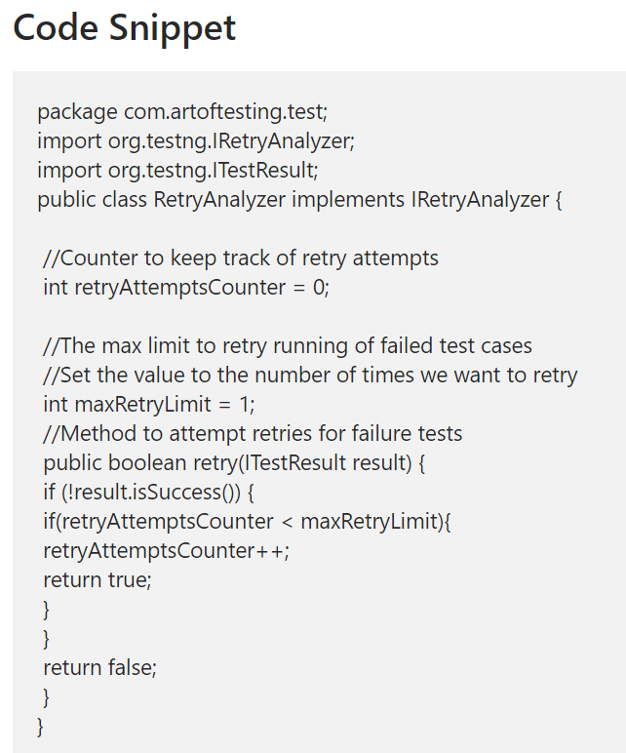
- Also, we can set this via listener.
- We can implement the IAnnotationTransform interface on RetryListener class level.
- Then we can define the retry logic transform() method.
- Then, In suite file, we can define the listeners xml tag.
- Then call the class RetryListener class.
- This will apply the for all the test case classes and we don’t need to set retryAnalyzer in @Test annotation level.

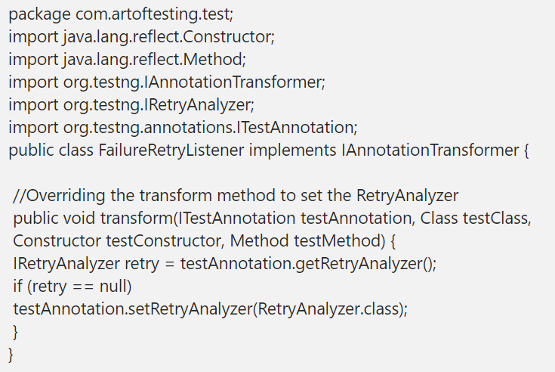
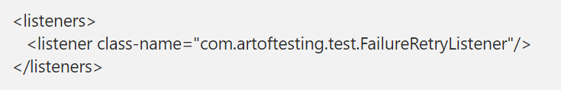

Listener -
- Listeners is using to listen the events of testcase scripts.
- We can implement the Listeners by using ITestListener interface.
- Also, Listener interface contains list of in-built methods like.
  - onStart() – this method will trigger while test suite are started.
  - onTestSuccess() – this method will trigger once test case method success.
  - onTestFailure() – this method will trigger once test case methods failed.
  - onTestStart() – this method will trigger once test case method get started.
  - onTestSkipped() – this method will trigger while test case method getting skipped.
  - onFinish() – this method will trigger while test suite are completed.
- Also, we can define the listener on suite file with <listener> tag.
- With in the tag, we will define the <run> tag and define listener class.
- If we want to implement the listener on particular class level, we can use the @Listener annotation on top of method signature and define the class name like
  - @Listener(Listenerclassname.class)

Locators -
- Locators are using to find the web elements on html page.
- There are like
  - Id
  - Name
  - Class name
  - Tag name
  - Link Text
  - Partial Link Text
  - CSS Selector
  - Xpath

Priority order of Locators in selenium -
- Id
- Name
- Class name
- CSS Selector
- Xpath

xpath -
- Xpath means XML path.
- We can find the web elements to navigate the structure of web pages HTML.
- There are 2 types of xpath like
  - Absolute xpath
    - Absolute xpath will start from Root node of HTML element in the DOM.
    - Also, it’s start with single forward slash (/)
    - If any changes happened in attribute beginning from root of the element then absolute xpath will be getting failed to locate the element.
    - Absolute xpath is lengthy and it’s difficult to maintain
  - Relative xpath
    - Relative xpath will be start by referring to the element that we want to identify and not from the root node. It will start from Middle of HTML element.
    - Relative xpath will start from double forward slash (//).
    - Relative xpath is short when compare to absolute xpath.
    - We can write relative xpath like //tag[@attribute = ‘value’]

FE vs FS (findelement vs findelements) FEFS -
Find Element | Find Elements
Find element is using to find the single web element | Find elements will find the multiple web elements.
Find element return type is a WebElement | Find elements return type is a List<Webelement> (List of WebElemenets)
If the element not found then find element will throw NoSuchElement Exception | Find elements will not throw any exceptions if the element not found. It will return Empty List.

Wait -
- Wait is using to halt the test case execution particular amount of time.
- And it’s useful to handle Ajax call on web pages.
- Also, It’s helps to create stable automation.

Types of Waits Selenium -
- There are few types of wait like
  - Sleep
  - PageLoadTimeOut
  - setScriptTimeout
  - Implicit Wait
  - Explicit Wait
  - FluentWait.
- Sleep – it’s a java thread method which is using to halt the execution for particular amount of time.
  - We can define class Thread.sleep(milliseconds)
- PageLoadTimeOut – it’s using to verify the web pages are loading on particular time or not.
  - We can define like “driver.manage().timeouts().pageLoadTimeOut(10, TimeUnits.seconds)”
- setScriptTimeOut – it’s using to verify the javascript files are loading in particular time are not.
  - We can define like “driver.manage().timeouts().setScriptTimeOut(10, TimeUnits.seconds)”
- Implicit wait - it will inform to webdriver to wait particular time.
  - For example:- ajax call.
  - We can use the implicit wait on ajax calls until it’s get finish.
  - If the elements are not visible on particular time, then it will throw “No Such Element Exception”
  - We can define implicit wait like
    - Driver.manage().timeouts().implicitWait(10, TimeUnit.Seonds);
- Explicit wait -
  - Explicit wait will halt the webdriver to proceed execution until particular condition are satisfied.
    - For Example:-
      - While present alert on web page
      - Visibility of particular web element
      - Check if element to be clickable
      - Check if element to be selectable.
  - We have to create the instance for class “WebDriverWait” for use the explicit wait.
    - Example:- WebDriverWait wait = new WebDriverWait();
  - Also, It contains in-built methods like
    - alertIsPresent()
    - elementToBeClickable()
    - elementToBeSelected()
    - visibilityOf()
    - title()
    - textToBePresentInElement().
  - If the element not visible on particular time, it will throw “ElementNotVisibleException”.
- Fluent wait -
  - It’s used to define maximum time for web driver to wait for condition.
  - Also, it will frequently will check the condition within given time period.
  - It will check the regular interval until the element is found.
  - If the element is not found, then it will throw “ElementNotVisibleException”
  - We create the instance for FluentWait then we can use it.
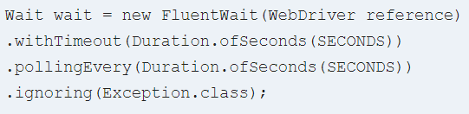

alerts -
- Alert is like a pop-up window which is used to display the notifications on web page.
- Also, we can’t locate the alerts with help of locators because it’s a browser native pop-up.
- To handle the alert, we can use the method like
  - Driver.switchTo().alert()
- We can accept and dismiss and getcontent of the alerts with help of method like
  - Driver.switchTo().alert().accept()
  - Driver.switchTo().alert().dismiss()
  - Driver.switchTo().alert().getText()
- Also, Alert are implemented via “Alert” interface.
- We can verify if alert is available or not by using explicitwait condition like
  - If(wait.until(ExpectedConditions.alertIsPresent()) == null)
  - Then alert not present
  - Else alert present

BrokenLinks bl -
- Broken links are like non-working links on web application.
- We can get the list of broken links by using method like.
  - Driver.findElements(By.tagName(‘a’))
- FindElements methods will return the List<WebElement> (List of web elements).
- Then, I will loop the List and get the attribute value of “href” in anchor tag (‘a’ tag) by using getAttribute(‘href’) method.
- Then, I will create instance for the URL like
  - URL url = new URL();
- Then I will use the HttpURLConnection class and initialize the method openConnection();
- Then I will set the timeout by using setconnectionTimeOut(milliseconds) method.
- Then, I will call the connect() method.
- Also, I will compare if the getResponsecode() method equals 200 then url is working fine.
- Else, links is like broken, Then I will call the getResponseMessage() method get response message.

iframe -
- Iframe are used to load child frame with in the parent frame.
- Iframe are separate page which is loaded in to single html page.
- In Html page, iframe are declared with tag <iframe>
- We can switch to iframe by using method like
  - Driver.switchTo().frame()
  - We have pass the webelement of iframe with in frame() method.
- If we need to switch back to parent window then we can use methods like
  - Driver.switchTo().defaultContent()
  - It will return to parent frame.

dropdown dd -
- Dropdown is the one of the webElement in html page.
- There are 2 types of dropdowns are there.
  - Single select dropdown
  - Multi-select Dropdown
- We can handle the dropdown by using “Select” class.
- We have to create the instance for the select class like.
  - Select variable_name = new Select();
  - We have to pass the dropdown locator as an argument in Select class.
- Also, Select class contains list of methods like
  - selectByIndex() – use to select dropdown values by index.
  - SelectByValue() – use to select by value
  - SelectByVisibleText() – use to select by visible text.
  - getOptions() – get the all options from Dropdown.
  - getAllSelectedOptions() – get all the selected values from Dropdown
  - isMultiple() – check if dropdown is multi or single select
  - deselectByIndex()
  - deselectByValue()
  - deselectByVisibleText()
  - deselectAll()

actions -
- In this case, we can use the actions class.
- Actions class is using to perform the mouse and keyboard actions.
- We can create the object for Actions class like
  - Actions variable_name = new Actions(Wevdriver);
- Actions class having inbuilt methods for mouse and keyboard events like.
  - moveToelement(target_element) – which is using to move the mouse to target element.
  - Contextclick() – to Perform the right mouse click operation.
  - DragAndDropBy – to Perform the dragging the object.
  - DragAndDrop – to perform the drag and drop the object.
- Also, at end of the action we need to call the Build().Perform() method to perform the actions.

window -
- we can handle the windows by using getWindowHandle() and getWindowHandles() method.
- getwindowHandle() method used to get the current window id like where we are present now.
- getWindowHandles() method used to get the list of opened tabs and new windows.
- Also, getwindowHandles() will return type will be Set<String> (set of string)
- To Move on to child window or another window, we can use driver.switchTo().window() method and have to pass the window id.

screenshot -
- We can use the TakeScreenshot interface to capture the screenshot in selenium.
- First we have to assign the driver on TakeScreenshot interface like
  - TakeScreenshot scrshot = (Takescreenshot)webdriver;
- Then we have to call the getScreenshotAS method and pass the OutputType.File as a argument like
  - File src_file = scrshot.getScreenshotAs(OutputType.FILE);
- Then copy the screenshot to the target location by using file utils class like
  - FileUtils.copyFile(srcFile,DestFile);

Screenshot Failed Test Cases -
- We can create the Listener class and call the capture screenshot method on onTestFailed method.
- Whenever test cases are getting failed, onTestFailed method will call the capture screenshot method and copy the screenshot on target location.

git -
- Git is like a version control tool. We can use the git to store our source code.
- Git has remote repository like github. Which we can maintain our source code on centralized repository.
- We can push and pull the code with repo repository via GitBash.
- Git has a commands like “git init”, ”git clone”, ”git add”, ”git commit”, “git push”, ”git pull”, “git switch”, “git status” like that.
  - git init – command is using to initialize the new repository in local.
  - git clone “url” – command is using to clone the remote repository into local repository.
  - git add “file name” – command is using to add the new file changes and modified existing file changes into local repository.
  - git commit -m “commit message” – command is using to commit the changes into local repository.
  - git push origin branch name – command is using to push changes into specific remote repository branch.
  - git pull – command is using to pull files and code changes from remote repository to local repository.
  - git switch branch name – command is using to switch one branch to another branch.
  - git status – command is using to verify local and remote repository working directorys are sync or not.
  - git stash – command is using to takes our uncommitted changes (both staged and unstaged), saves them away for later use, and then reverts them from your working copy

git conflict -
- git conflict usually will happen when we try to merge the changes from different branch and if team members working on the same file and if they try to push the code, git conflict will occur.
- But Git unable to resolve those conflict automatically so we need to resolve the conflict manually.
- We have to follow the few process to resolve this conflict issue like.
  - First we need to identify the conflict files.
  - Then we need to open the conflict file in notepad
  - And review the changes for conflict in those files. Usually git will show the incoming changes with red colour annotations and it will show the existing changes as well.
  - Then we need to collaborate with team members and take the backup of our current code changes and pull the code from remote again.
  - Then we have to add our code changes in that file and save those changes.
  - Then we can add out changes by using “git add” command.
  - Then we need to merge our coding changes by using “git merge --continue” command.
  - After that, we can push our coding changes to remote repository.
  - In this way, we can resolve the git conflict.

Jenkins -
- Jenkins is an open source and automation server which is using to perform CI / CD process.
- Also, we can trigger the maven builds and run the selenium scripts.
- In Jenkins, we schedule the cron time to trigger selenium scripts also we can configure the email notifications. Notification will be send to respective team members, if test cases are failed.
- We can install the Jenkins via native system package (or) Jenkins.war file.
- Also, Once Jenkins installed, we can access the Jenkins portal with credentials.
- Also, we can configure the Git on Jenkins with maven commands.
- Whenever push the code changes into git master branch, it will trigger the Jenkins pipeline and run build.

Continues integration CI -
- It’s part of application development process.
- When developer made changes on application code, pipeline will triggered and create build for the changes.
- In my project, we have used Jenkins to perform CI / CD.
- We have configured the git with Jenkins plugin and configured the git credentials.
- Once we trigger the code changes into master branch, then Jenkins pipeline will trigger and it will create the artifacts.
- We will store the artifacts in JFrog Repository.
- Also, we will use jfrog plugin in Jenkins and configured with jfrog access token.
- Those process is usually called Continues Integration.

Continues Deployment CD -
- Continues deployment is like once CI process completed, build will be deployed automatically via Jenkins pipeline.
- In My project, we have Dev, SIT, Pre-PROD, PROD environments.
- Once CD process is triggered, builds will be deployed on SIT and PRE-PROD environments.
- Also, we can set the Approval for each environment like stage.
- If the build is not stabled, then approvals will be rejected.
- My Team Lead and Project Manager will have an authorization to approve the builds on different stages.
- Those process is a Continues Deployment.

Configure the build jobs on Jenkins -
- We have to open the Jenkins portal.
- Click the New items menu.
- We can choose Maven Project
- Then we have to go to configure system settings.
- Then we have to click Add JDK button and mention the installation path on JAVA_HOME variables.
- Then we have to select the Build section
- Then Mention our maven project POM.xml root path.
- Then we have to define the maven goals like “clean test”
- Then click apply.
- Also, We can setup the email notification on Build settings.
- Then, we can run the build.
- Also, we can check the logs on Build console.
- To trigger jobs automatically, we can go to Build trigger then select Build periodically check box.
- Then we have to provide the crone timings like in how frequently job will be trigger.

Web Service -
- Web service is a application which is using to handle the data (like fetch and send) between client and server.
- There are few types of web services like SOAP (simple object access protocol) and RESTful (Representational state transfer).
- Also web services contains different components like WSDL (Webservice description Language) and XML.
- We can use the Http protocol and send the data in XML format over the network.

Web Services VS API:-
API | Web Services
API provide response in XML, JSON and text format | Web services response mostly will be XML format
API based on URI and it’s using HTTP and HTTPS protocol for data transfer | Web service need soap and HTTP protocol to send and receive the data over the network.
Also, API architecture is light-weight | While compare to API, Web services architecture is little complex

API -
- API means Application Programming Interface. It’s using to exchange the data between the applications.
- API will be act like an interface between the two applications and it can transfer the data between them.
- It’s kind of request and response format.
- API will be called by URL and we can pass the necessary parameters to get the data from the database.
- There are several HTTP methods are there like “GET”,”POST”,”PUT”,”DELETE” So on…

API Testing Types:-
we can perform the API testing like
- Functional Testing
- Unit Testing
- Load Testing
- Security Testing
- UI Testing

API Tools:-
- In my project, I have used postman rest client tool to validate the API responses.
- We can get the API endpoint URL and paste into Postman tab header.
- Then we have to choose HTTP request method type like “GET” or “POST” or “PUT” or “DELETE”.
- Then we can pass the parameters in parameters section with key-value pair combination.
- Also, In authorization header, I have used the API_KEY and Bearer Token, OAuth2.0 based on our requirement and will pass security token either query parameter or header.
- In the Headers, we can pass the list of API headers.
  - For Example:- If the API request the JSON formation then we set content-type = application/json so on..
- Also, In the request body, we can pass the object as a raw type then we can click the send button.

Collections on Postman PM -
- Collection is the one of the features in postman. We can use collections to store the group of request and we can reuse them.
- In single collections, we can store the multiple API endpoint URL’s and we can save it.
- We can create the multiple collections in postman based on our requirement.

API Http Methods -
- We have methods like “GET”, “POST”, “PUT”, “DELETE”
- GET – it’s using to fetch the data from the database.
- POST – it’s using to store the data into database.
- PUT – it’s using to update the existing data/resources on database.
- DELETE – it’s using to delete the data on database.

POST vs PUT vs Patch:-

POST | PUT | PATCH
Post will send the data to server | Put will update the data on server. Example:- if user click the edit and modify the information, All the entries will be re-updated. | Patch will modify the particular data on server.  Example:- if user click the edit and modify the information, only new changes will be updated. Existing entries will not be affected.

HTTP Status Code Status -
- 200 – it means everything working fine. All the request and responses processed successfully.
- 201 – means, new request created. For example, if user perform the sign up the form on portal, and submit the request, it will return the response like 201.
- 204- success but empty value
- 400 – means bad request. For example, it’s kind of client error. Server will process the request due to invalid syntax or invalid request message framing so on..
- 401 – means unauthorized. If user don’t have a permission to access the particular resources.
  - For example:- in database, we have roles in each user like Developer and Manager. If developer role person access the resources which is belongs to Manager role, we will get unauthorized error.
- 403 – means forbidden. Client doesn’t have the permission to access the any kind of resources.
  - For example:- If any unknown users try to access the API endpoint, server will verify the identity.
  - If the identity didn’t match, then server will reject the request.
- 404 – means not found. If the particular request not available for the request, then it will throw the Not found error.
- 500 – means internal server error. Some issues on server level. So server will not accept the client request.
- 503 – means service unavailable. Server might not ready to accept the client request.
  - It may be happen due to server down due to maintenance or heavy load on server.

Advantages of API Testing:-
- We can access the application and validate the data without user interface (GUI).
- API testing will take less time consuming while compare to UI testing. So it will help to provide better and faster test coverage while compare to the UI testing.
- API testing like a language independent. Usually data will be exchange the via XML or JSON. So we can use any code languages like java, Python, Node js to perform automation testing.
- Also, we can check the request and response via client tools like postman. We don’t need to open the UI.

Common Testing performed API testing:-
- In API, we can validate like
- Response of the API should be verified based on the request. We will verify that the return value is based on request.
- When API is updating any data structure we should verify the system is authenticating the outcome.
- We will verify whether the API is trigger other event or request another API.
- We will verify the behaviour of the API when no value is return.

API testing verify:-
- We need to verify the few things like
  - Data Accuracy on API response.
  - HTTP status code.
  - Also, we have to check the response time.
  - We have to validate the authorization.
  - Non-functional testing like performance and security testing.

Types of web services -
- There are two types of web services like
  - SOAP (Simple Object Access protocol) – SOAP is XML based method.
  - RESTFUL – Rest is HTTP based methods. It will provide the response in JSON format.

Resources in REST -
- Whatever content we used in rest API is usually called resources.
- It can be like text files, HTML pages, images so on.
- We can represent the resources like text, JSON and XML format. But mostly, we will use JSON and XML.

Rest Assured RA -
- It’s a java library to perform the API testing automation.
- We can integrate the rest assured library with maven dependency and can use along with testNG.
- Also, it will work based on JSON and XML Format.
- And it will support the all the HTTP methods like “GET”,”POST”,”PUT”,”DELETE” so on..
- Also, we can used the methods like
  - Given(), When(), Method(), Then().
  - Given() – we can pass the context like api baseuri, request headers, query and path param, request body, ,cookies. This is optional if these items are not needed in the request.
  - When() – we can call this method while we perform like when we do get/post/put/delete operations.
  - Method() – it’s a submethods of when method and we can define method type like get()/post()/put()/delete()
  - Then() - Then Method using to perform assertion with matched condition by using Matchers class methods
    - Example:- we can check the status code of the request by using statusCode() method.
    - We can validate and assert the response body then validate the expected and actual response data by using Matcher class method like equalTo() method .

Method Chaining RA -
- Method Chaining is like a syntax which is using to call the number of methods in sequence order.
  - Example like Give().When().Then()
- Each method compare the objects and chaining of several method calls in single line.
- While we use method chain, we don’t need to use the variable to store the result. We can call the multiple method in single line itself.

Request Specification RA –
- Request Specification is an interface which is using to group similar request specifications and transform them into specific object.
  - Example like:-
    - RequestSpecification variable_name = RestAssured.given();
    - Variable_name.baseUri(“api uri”)
    - Variable_name.basePath(“/apiname”)
- And we can store the response using Response interface

Static Import RA –
- Actually we are using static import to improve the readability in rest assured classes like we can simplify the testcase scripts while using given() and matchers class methods, If we are not using the static import like
  - Import static io.restassured.RestAssured.*
- Then we need to call the rest assured method along with class name.
  - Example like:-
    - We can call the given() method like RestAssured.Given()

CUCUMBER Bdd -
- Cucumber is a BDD (Behavior-driven development) framework.
- We can write a test cases in cucumber than easily can understand Non-technical peoples.
- Generally, Cucumber using Gherkin language. It’s like a plain text. So that anyone can understand what we have return.
- Cucumber contains some list of few keywords like Feature, Scenario, Scenario outline, Rule, Example, Given, When, Then, And, Background.
- Those keywords we can use it in “feature” file.
  - Feature – in feature, we will define the high-level description of the software feature.
    - For example:- if we want to validate the functionality like search or login, we can define like in the feature.
  - Rule – rule we will use to define the business rules of the application.
    - For example:- in login page, username name should be email id (or) phone number. We can define this on rules keyword,
  - Scenario – Every feature can have multiple scenarios.
    - For example:- we define scenarios like “verify login page” and “verify home page” so on… we define that in feature file.
  - Scenario Outline – Sometimes we need to run the test scenario for multiple times. In this situation, we can use the scenario outline in feature file.
    - For Example – we can define same scenario multiple times like “verify login with phone” and “verify login with email id”. We can define that in scenario outline.
  - Example Keyword – it’s one of the keyword in feature file. We can provide the multiple input for the same scenario.
    - For example:- if we need to validate login functionality with different username and password.
    - we can pass the different username and password credentials for same scenario.
    - Same login functionality Test case will be executed each and every for each user credentials.
  - Given - given steps are used to describe the system's initial context.
    - For Example:- in Given keyword, we can give the Enter browser url .
  - When – it will trigger when the particular action in the application.
    - For Example:- when the login page visible on page.
  - Then – then keyword will follow up with when action.
    - For example:- when Login page is displayed then we have send the username and password.
    - We can define this on feature file along with Then keyword.

Feature in cucumber:-
- WE CAN STORE THE Feature is file which are stored the list scenarios and scenarios outline of the application.
- Depends on the requirement, we can create the multiple feature files in cucumber framework.
- Feature will be ends with “.feature” extension.
- Then we can use the sptep

Step Definition:-
- Step definition is a java class file which is using to execute the steps which we already define on feature file.
- We can create the separate java methods for each steps of features.
- Also, we can use the annotations like @Given, @When, @Then, @And, @But on top of methods signature.

Test Runner:-
- Test runner is a java class file which is using to map the feature and step definition.
- We can use the annotation like @CucumberOptions and we can use the attributes like “features” and “glue”, “tags”, “plugins”.

Azure az -
- In my project, I have used Azure Boards, Repos, Azure Pipelines so on.
- For Azure Borad, we have used to manage and maintain all the Tickets.
- Also, I have created Ticket and raise the bug in work items section.

Browser options opt -
- In selenium options class is used to set the options for browsers while execute like verify SSL certificate and handling the browser based pop-up, and verify if page loading strategy.
- Also we can use options class to confirm the if the pages loaded completely before selenium execute the commands.
- We can create the instance for options classes and verify the page loading like
  - ChromeOptions variable_name = new ChromeOptions();
  - Variable_name.setPageLoadStrategy(PageLoadStrategy.NORML);
  - WebDriver driver = new ChromeDriver(options_variable_name)
- Once we set the PageLoadStrategy as NORMAL then webdriver wait till the DOM content of page loading is completed.

Json -
- I have handle the json by using google json maven dependency.
- In my project, some test input data we maintained on json and passed those input data to automation script web elements.
- First I will create the object for File Reader to locate and read the json file.
- Then I will create the object for JSONParser class and pass the filereader object to the json parser object.
- And create the JSONArray object and pass the JSONParser object to JSON Array.
- Then we can loop the JSONArray and get all the json object and stored into JSONObject class.
- And we can get those object key-value pair by using get() method.
- And pass the values to the selenium web elements.

Garbage Collections gc –
- Garbage collector is like to clean unwanted objects from the memory and it’s helping to retain the memory space.
- Mostly it’s using to handle the unreferenced objects like
  - If object reference is null
  - Or if object assign the reference to another reference
  - And like unused and anonymous object.
- Before garbage collector is execute, finalize() method is executed each time to perform clean up.
- Then gc() method will execute to complete the clean up process.
- We can explicitly call the garbage collector method like
  - System.gc();

